Brain Tumor Prediction and Image Processing

Nandhitha Ravishankar, P Sadhana, Dr. Suja P

Department of Computer Science and Engineering (Artificial Intelligence)

Amrita School of Engineering, Bengaluru  
Amrita Vishwa Vidyapeetham, India

nandhitharavishankar@gmail.com, psadhana2002@gmail.com, p_suja@blr.amrita.edu

Abstract—*Early diagnosis of brain tumors plays an important role in a patient’s treatment and makes it easy to save his/her life. The conventional method of manually detecting brain tumors from brain magnetic resonance imaging (MRI) scans can be problematic and erroneous. This paper presents an automatic brain tumor detection using CNN and also have performed Image Processing to analyse and understand the images. An accuracy of 61.25% was obtained. A GUI was created on MATLAB to visualise the analysis outputs for the images*.

Keywords – *Brain Tumor, CNN, Deep learning, MATLAB, Image Processing*

1. INTRODUCTION

A lump or growth of abnormal cells in your brain is known as a brain tumor. There are numerous varieties of brain tumors. Both benign (noncancerous) and malignant (cancerous) brain tumors can occur (malignant). Primary brain tumors are those that start in the brain; secondary (metastatic) brain tumors are those that start in other regions of the body and spread to the brain.

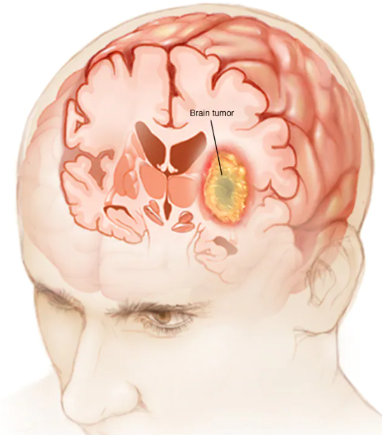

Fig.1 Brain Tumor

Manually detection the presence of tumors in not an easy task for the doctors. Using algorithms give a higher accuracy for the output giving more guarantee.

In this research, the MRI images that are obtained from the dataset is analyzed on the basis of various methods such as opening, closing, dilation, erosion, edge detection, smoothening, sharpening, image coloring, contrast stretching, reflection, rotation, translation, scaling and sheering. This work was analyzed on MATLAB by creating a graphic user interface(GUI).

Brain Tumor presence is also detected in this project. Machine learning includes convolutional neural networks, also known as convnets or CNNs. It is a subset of the several artificial neural network models that are employed for diverse purposes and data sets. A CNN is a particular type of network design for deep learning algorithms that is utilized for tasks like image recognition and pixel data processing. The dataset is trained and run over 500 iterations to obtain an accuracy rate of 61.25%

1. LITERATURE SURVEY

[1] R. Rulaningtyas and K. Ain, "Edge detection for brain tumor pattern recognition," International Conference on Instrumentation, Communication, Information Technology, and Biomedical Engineering 2009, 2009, pp. 1-3, doi: 10.1109/ICICI-BME.2009.5417299.

This research developed a programme with edge detections method to provide doctors with edge patterns of the brain and the actual brain tumor in order to aid in the diagnosis of brain tumor grading. In this study, the initial stage in brain tumor grading research is edge identification of the tumor. Between the Robert, Prewitt, and Sobel methods, this research discovered the best edge detection method for detecting brain tumors. The Sobel technique is the one that works best for detecting brain cancers out of these three. Compared to the other two edge detection methods, the Sobel approach exhibited a lower deviation standard value.

This paper helps in the analysis part of the project to understand the working of edge detection.

[2] N. M. Dipu, S. A. Shohan and K. M. A. Salam, "Deep Learning Based Brain Tumor Detection and Classification," 2021 International Conference on Intelligent Technologies (CONIT), 2021, pp. 1-6, doi: 10.1109/CONIT51480.2021.9498384.

The cutting-edge object detection framework YOLO (You Only Look Once) and the deep learning library FastAi, respectively, are used in this study to present two deep learning-based methods for the identification and classification of brain tumors. A portion of the BRATS 2018 dataset, which included 1,992 brain MRI scans, was used for this investigation. The accuracy of the YOLOv5 model was 85.95%, and that of the FastAi classification model was 95.78%. These two models can be used to detect brain tumors in real-time for an early diagnosis of the disease.

This paper has been referred for brain tumor detection.

1. DATASET

The dataset was obtained from Kaggle that contained two folders having images of MRI Scan reports. One folder named yes contained images of those that have brain tumor and another one which was named no contained images of those that did not have brain tumor. Yes contains 155 images and No contains 98 images.

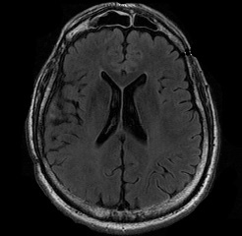 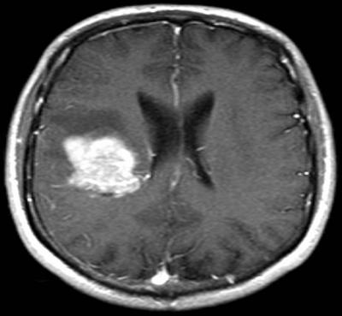

Fig.2 Absence of tumor Fig.3 Presence of tumor

1. IMAGE ANALYSIS

Image Analysis has been done using various techniques on MATLAB. A graphic user interface (GUI) has been created to visualise the outputs. Operations such as open, close, dilate, erode, contract stretching, reflection, sheer, scaling, sharpening, rotation, translation, smoothening, segmentation, edge detection and colouring have been performed.

Image is imported on browsing the required image through the dataset and those operations are performed on that image.

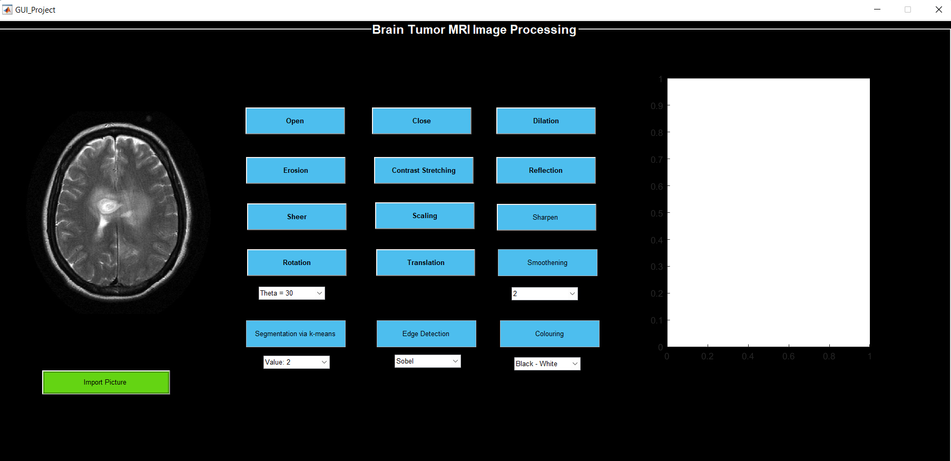

Fig.4 Importing the Image

[1] Opening

Opening removes small objects from the foreground (usually taken as the bright pixels) of an image, placing them in the background.

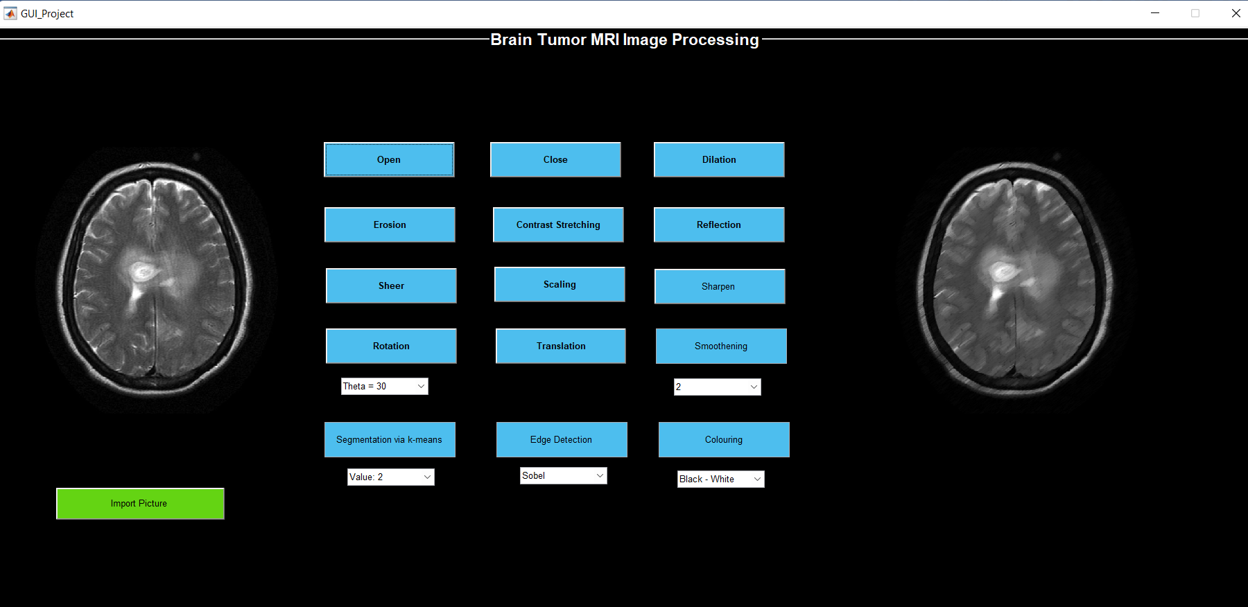

Fig.5 Opening of an Image

[2] Close

Closing removes small holes in the foreground, changing small islands of background into foreground. Closing is generally used to smoother the contour of the distorted image and fuse back the narrow breaks and long thin gulfs.

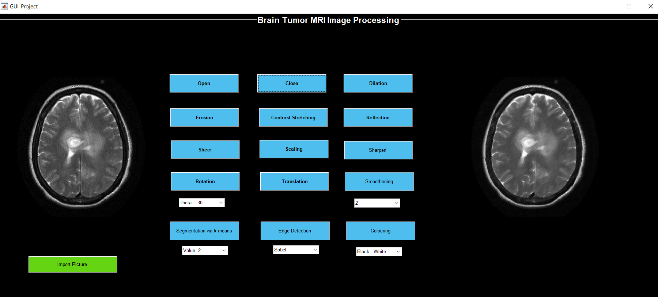

Fig.6 Closing of an Image

[3] Dilate

Dilation adds pixels to the boundaries of objects in an image. The number of pixels added or removed from the objects in an image depends on the size and shape of the structuring element used to process the image.

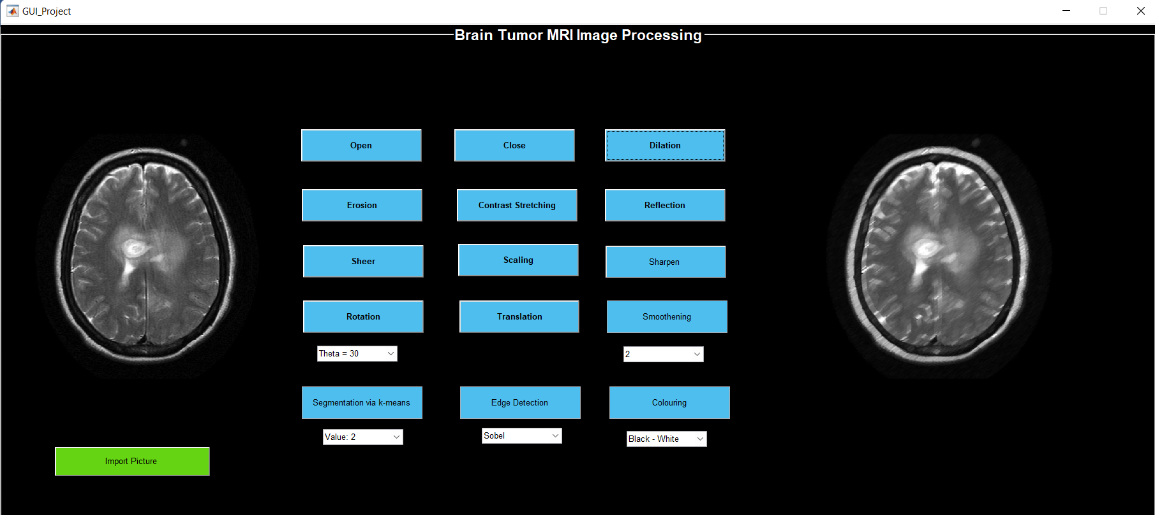

Fig.7 Dilation of an Image

[4] Erode

Erosion shrunken the image pixels i.e. it is used for shrinking of element A by using element B. Erosion removes pixels on object boundaries.

The number of pixels added or removed from the objects in an image depends on the size and shape of the structuring element used to process the image.

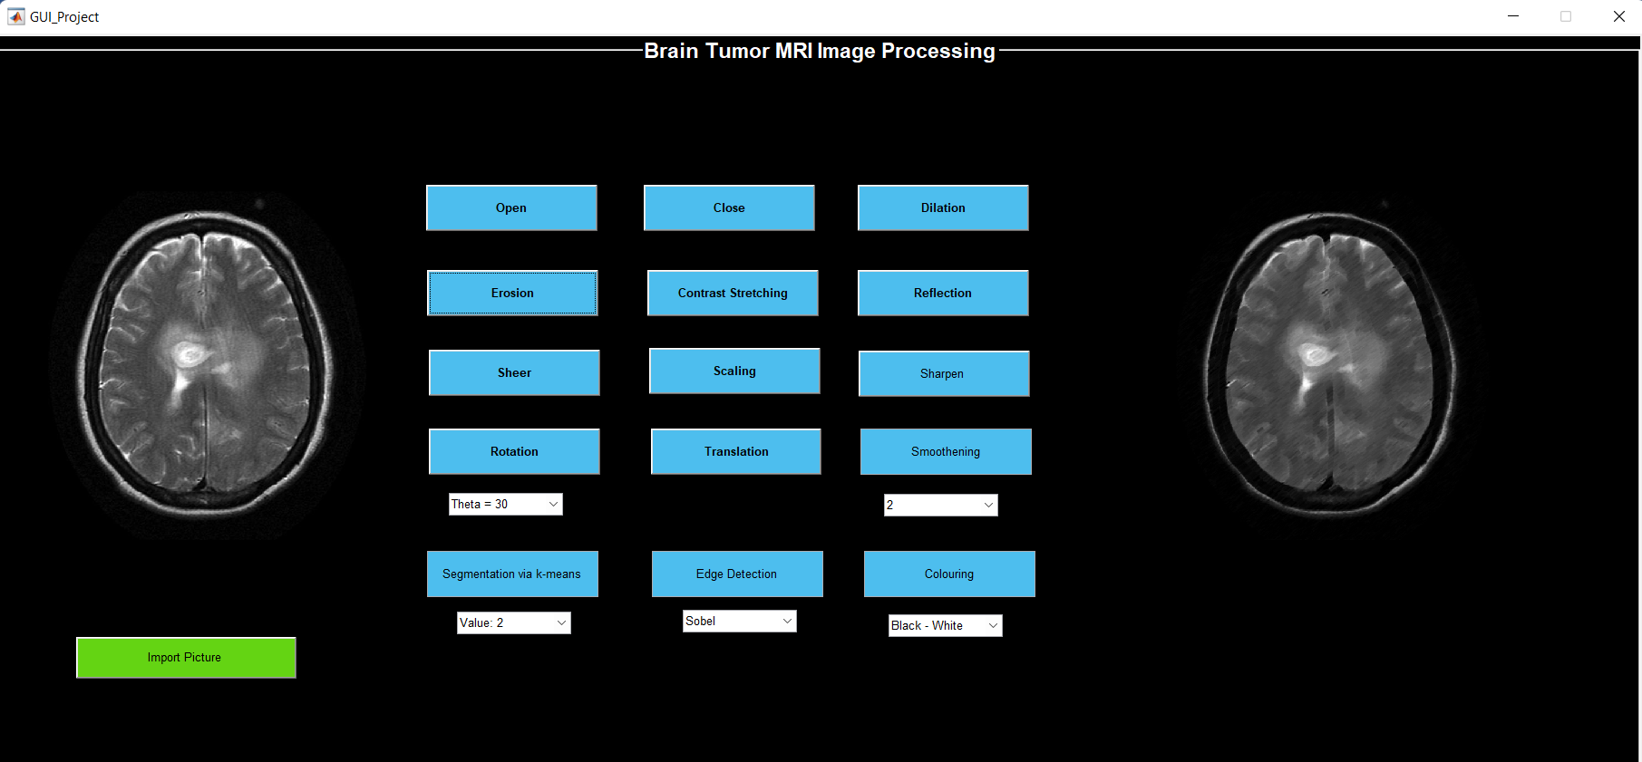

Fig.8 Erosion of an Image

[5] Contrast Stretching

Contrast stretching, also known as normalising, is a straightforward image enhancement technique that aims to boost contrast by "extending" the intensity values in a picture to cover a specified range of values, or the entire set of pixel values that the target image type permits.

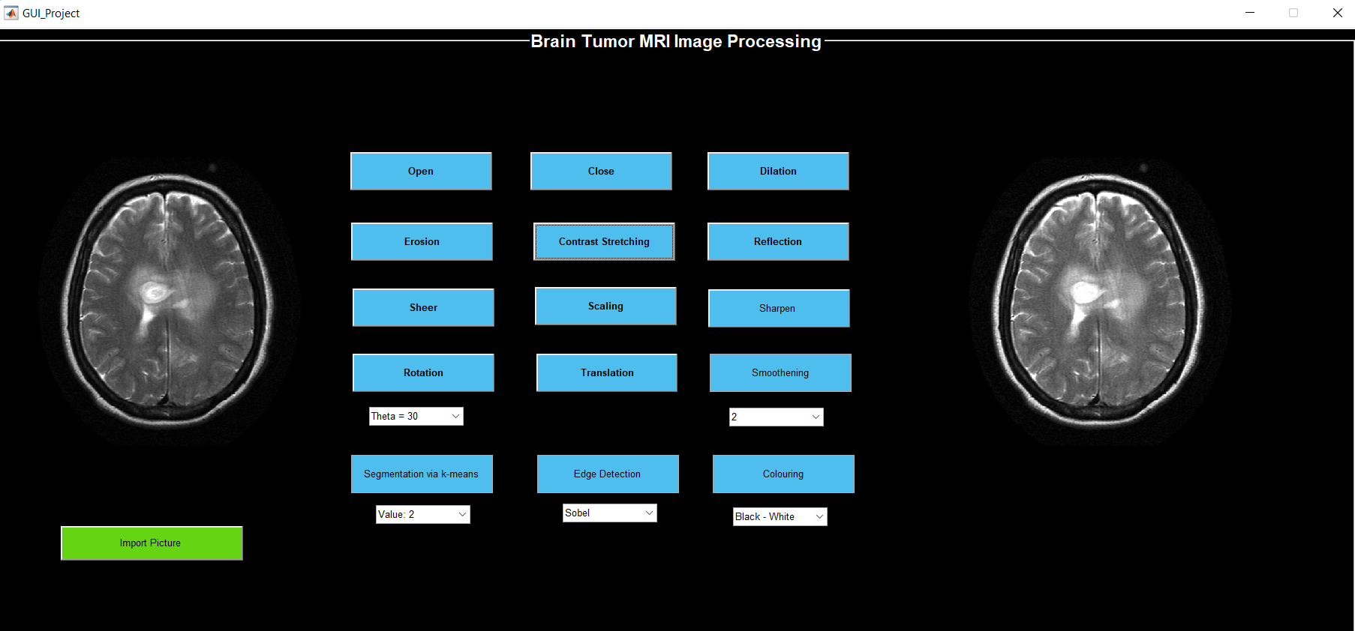

Fig.9 Contrast Stretching of an Image

[6] Reflection

The reflection operator geometrically repositions image elements, or pixel values, in such a way that they are reflected about a user-specified image axis or image point and placed in a new position in a matching output image.

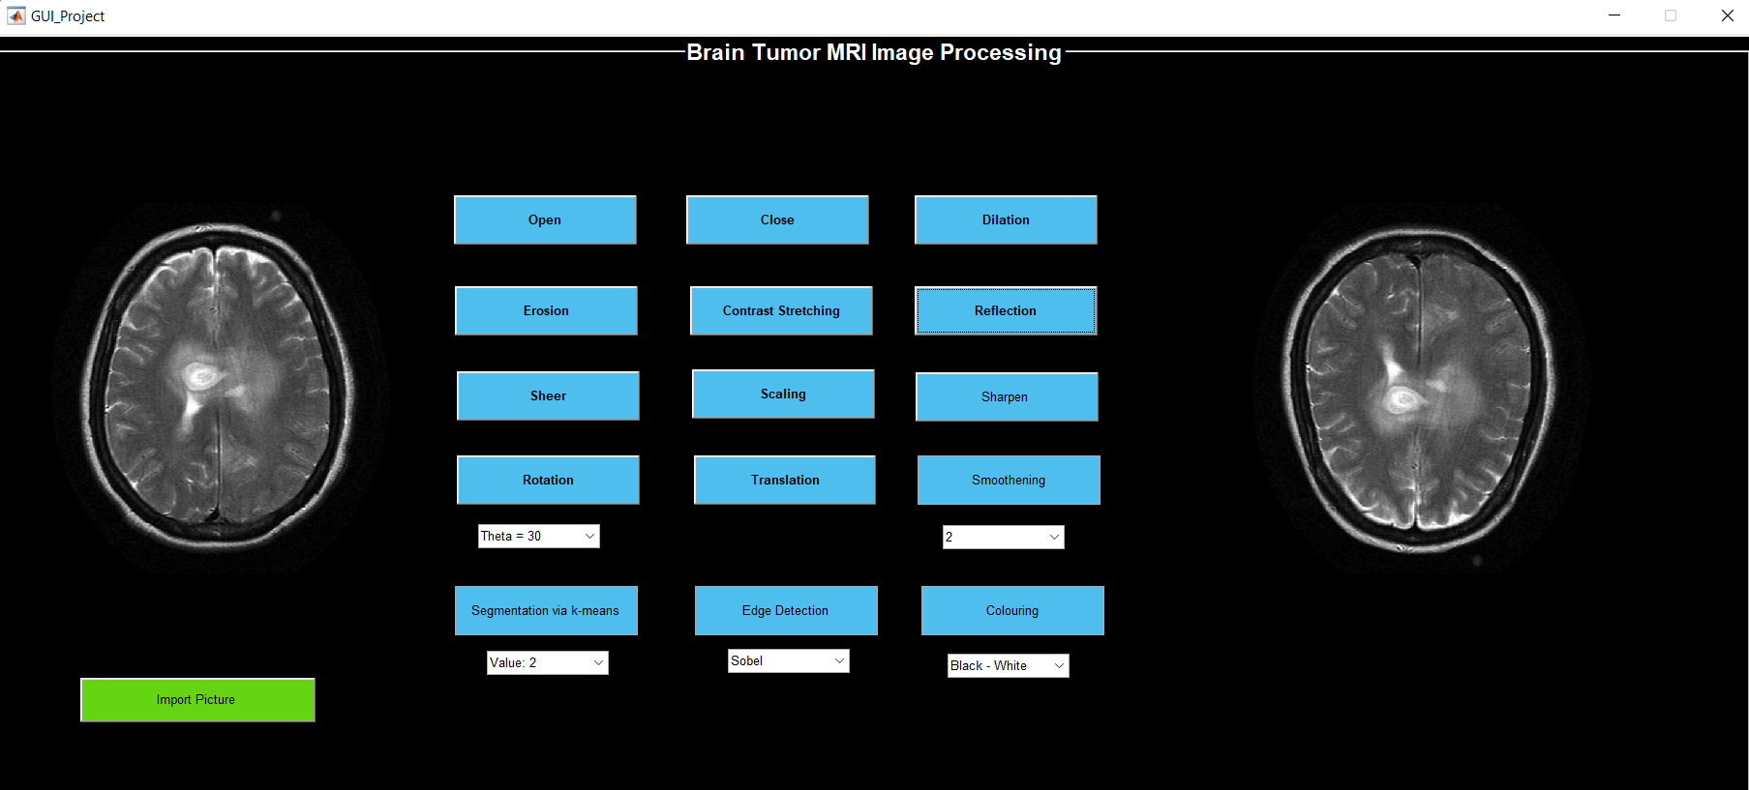

Fig.10 Reflection of an Image

[7] Sheer

With the shear tool, you can move one portion of an image, layer, selection, or path in one way while moving the other portion in the other direction. For example, if there is a horizontal shearing, the higher portion will move to the right and the lower portion to the left.

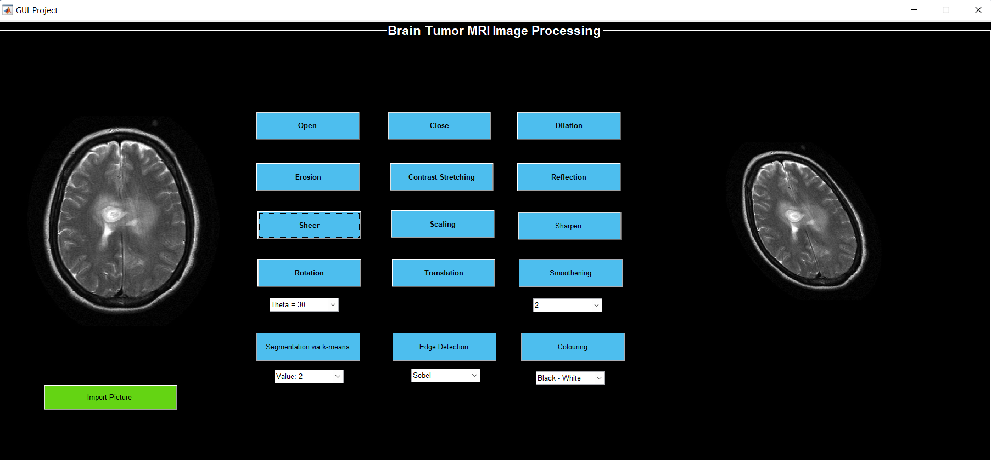

Fig.11 Sheer of an Image

[8] Scaling

When scaling, the pixels are stretched and may appear pixelated rather than being best adapted to the new size. When an image is scaled up beyond its original proportions, one of its most frequent side effects is that the image may appear very pixelated or fuzzy.

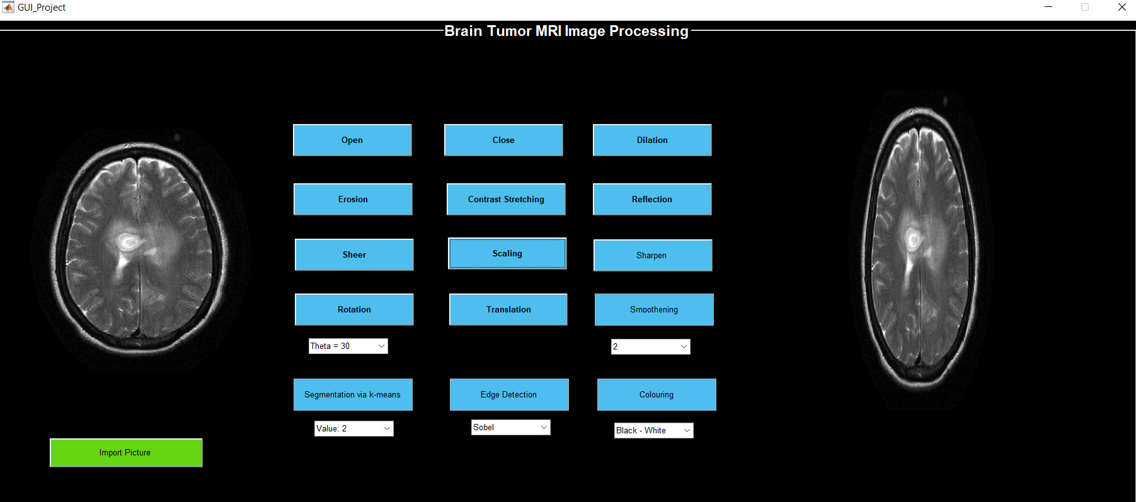

Fig.11 Scaling of an Image

[9] Sharpening

Any enhancing method that brings out an image's finer features and edges is referred to as sharpening. In order to improve the local contrast and sharpen the images, image sharpening is frequently employed in the printing and photographic industries.

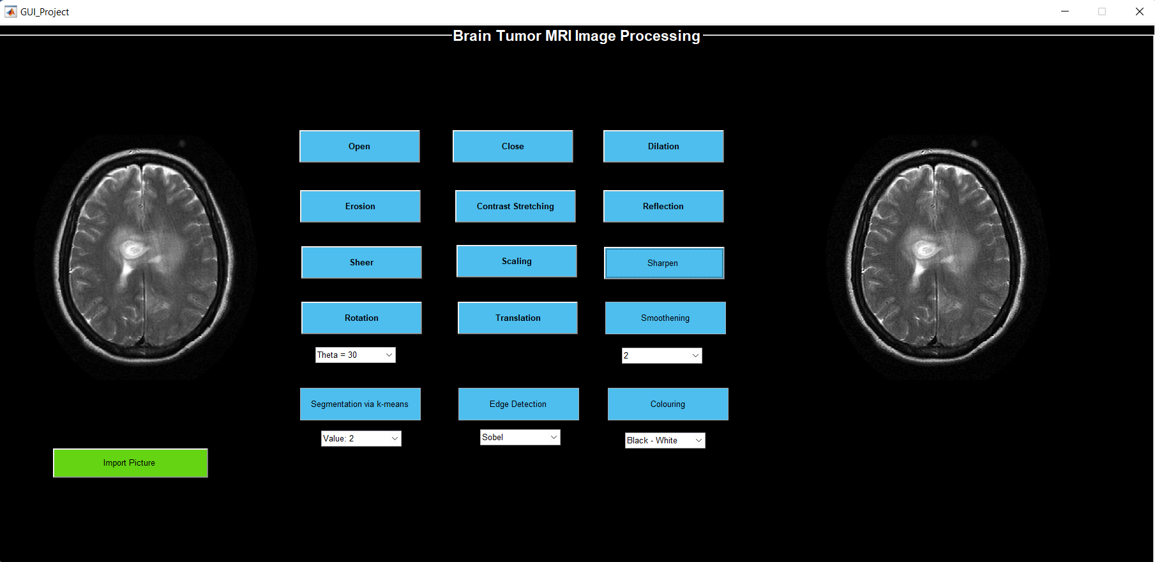

Fig. 12 Sharpening of an Image

[10] Rotation

A typical image processing technique called image rotation is used in algorithms for matching, alignment, and other image-based tasks. A picture, the rotation angle, and the location around which the rotation is to be done are the inputs to an image rotation routine.

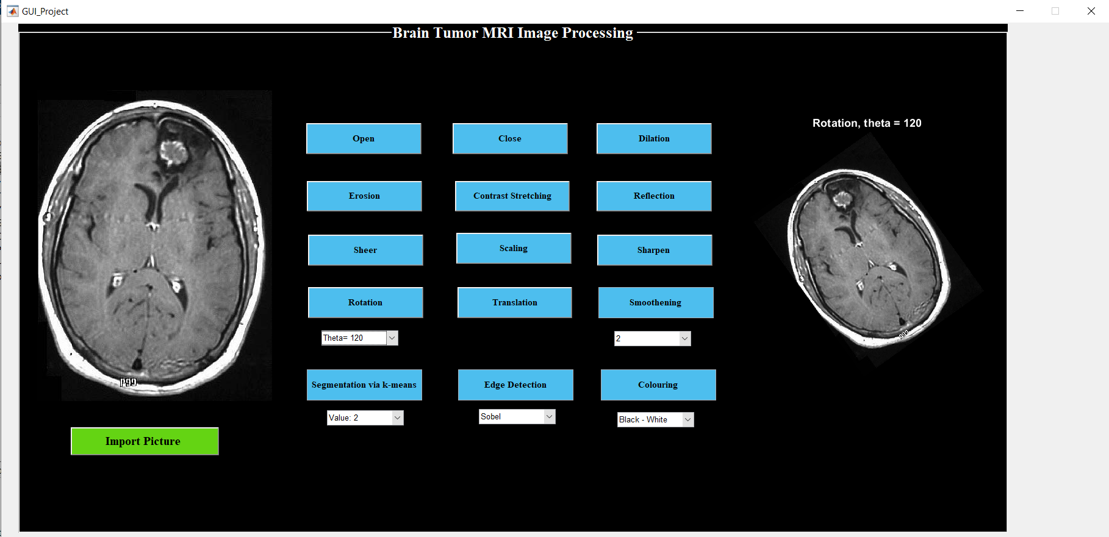

Fig.13 Rotation of an Image

[11] Translation

The process of converting a picture from one domain to another, known as "image-to-image translation," has as its objective learning the relationship between an input image and an output image.

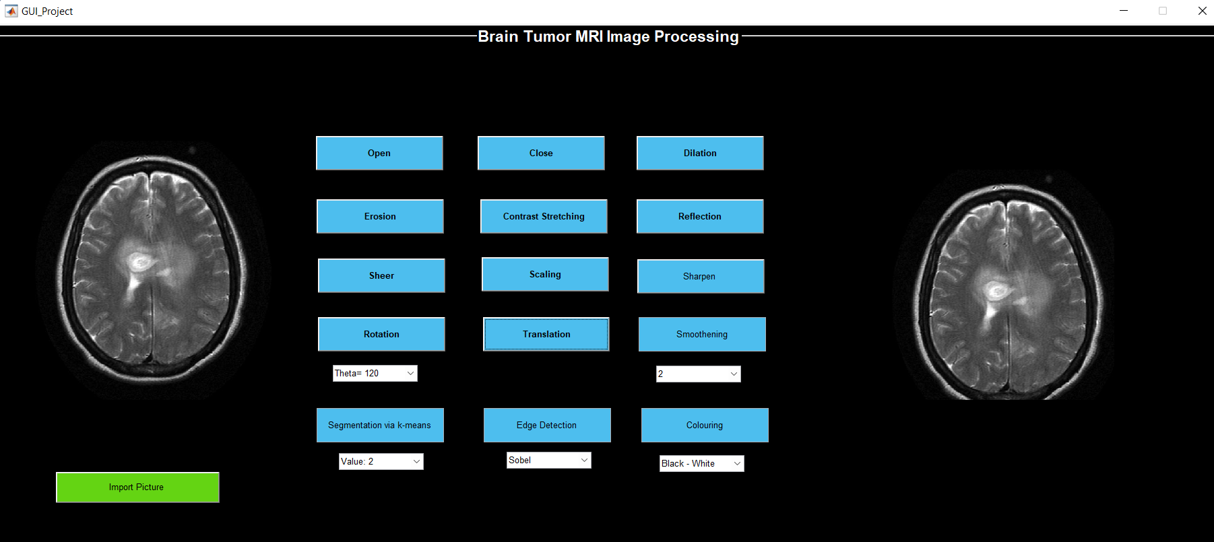

Fig.14 Trans of an Image

[12] Smoothening

Smoothing is used to produce images with fewer pixels and less noise. The majority of smoothing techniques rely on low-pass filters, but you can also use a kernel—a moving collection of pixels—to smooth an image by taking the average or median value of that group of pixels.

Fig.15 Smoothening of an Image

[13] Segmentation

Often based on the properties of the picture's pixels, image segmentation is a widely used method in digital image processing and analysis to divide an image into various parts or areas.

Fig16 Segmentation f an Image

[14] Edge Detection

Edge detection is a method of image processing that locates the edges of objects in pictures. It operates by looking for changes in brightness.

Fig.17 Edge Detection of an Image

[15] Colouring

Adding colour, to a black and white image has been done.

Fig18 Colouring of an Image

1. BRAIN TUMOR DETECTION

A deep learning network architecture that learns directly from data is a convolutional neural network (CNN or ConvNet).

CNNs are very helpful for recognising objects, classes, and categories in photos by looking for patterns in the images. They can be quite useful for categorising signal, time-series, and audio data.

WORKFLOW

LOADING THE IMAGES FROM THE MAIN DIRECTORY

IMPORTING THE REQUIRED LIBRARIES

PERFORM CNN

PLOTTING THE IMAGES

ANALYSE THE RESULTS

Fig.19 Flowchart

1. RESULTS

On running the model , we obtain an accuracy of 61.26%. a loss which is a number that indicates how bad the model is , is also obtained. A loss of 0.3080 was achieved.



1. CONCLUSION AND FUTURE WORK
2. he hand gesture recognition system was designed for recognition of ISL alphabets and digits
3. as well as static symbols of Indian Sign Language in a common vision based platform.
4. he hand gesture recognition system was designed for recognition of ISL alphabets and digits
5. as well as static symbols of Indian Sign Language in a common vision based platform.

With the advancement in technology, detection severe problems such as brain tumor has become easier. Using various deep learning techniques will give a higher rate of accuracy in the prediction and thus making treatment much easier. The model designed in this project gives an accuracy of 61.26% which can be also improved using other deep learning techniques. Moreover, analysing the brain MRI images, it helps to bring a better understanding of the images

1. REFERENCES

[1] N. M. Dipu, S. A. Shohan and K. M. A. Salam, "Deep Learning Based Brain Tumor Detection and Classification," 2021 International Conference on Intelligent Technologies (CONIT), 2021, pp. 1-6, doi: 10.1109/CONIT51480.2021.9498384.

[2] S. Handore and D. Kokare, "Performance analysis of various methods of tumour detection," 2015 International Conference on Pervasive Computing (ICPC), 2015, pp. 1-4, doi: 10.1109/PERVASIVE.2015.7087002.

[3] Deepa and A. Singh, "Review of brain tumor detection from MRI images," 2016 3rd International Conference on Computing for Sustainable Global Development (INDIACom), 2016, pp. 3997-4000.

[4] A. Jagan, "A New Approach for Segmentation and Detection of Brain Tumor in 3D Brain MR Imaging," 2018 Second International Conference on Electronics, Communication and Aerospace Technology (ICECA), 2018, pp. 1230-1235, doi: 10.1109/ICECA.2018.8474874.

[5] E. E. Ulku and A. Y. Camurcu, "Computer aided brain tumor detection with histogram equalization and morphological image processing techniques," 2013 International Conference on Electronics, Computer and Computation (ICECCO), 2013, pp. 48-51, doi: 10.1109/ICECCO.2013.6718225.

[6] G. Raut, A. Raut, J. Bhagade, J. Bhagade and S. Gavhane, "Deep Learning Approach for Brain Tumor Detection and Segmentation," 2020 International Conference on Convergence to Digital World - Quo Vadis (ICCDW), 2020, pp. 1-5, doi: 10.1109/ICCDW45521.2020.9318681.